**LAB 1 Computer Networks**

**K20-1052**

**S.M.HASSAN ALI**

**Find the IP address of the computer you are currently using.**

**Command: ipconfig**

**IP address: 172.16.10.83**

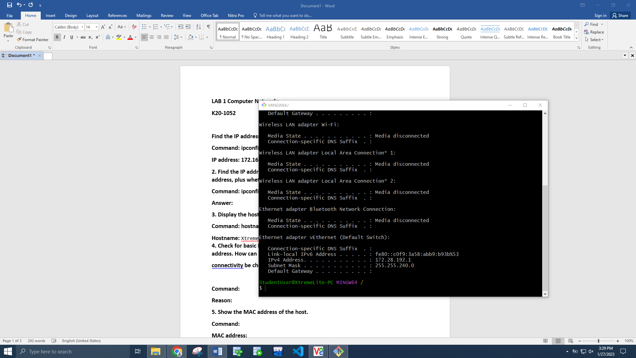

**2. Find the IP address of the computer you are currently using, plus MAC address, plus whether DHCP is turned on.**

**Command: ipconfig /all then see physical address (also known as Mac Address)**

**Answer:**

**3. Display the host name of the computer.**

**Command: hostname**

**Hostname:** XtremeLite-PC

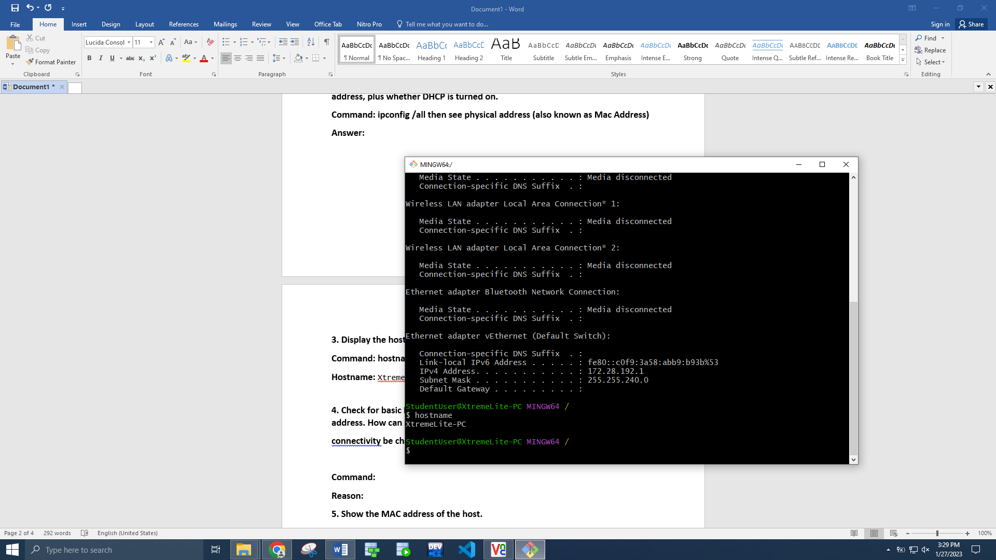

**4. Check for basic IP connectivity between two computers by name and IP address. How can basic IP**

**connectivity be checked? What are the reasons why there is no connectivity?**

**Command: ping 172.16.10.89 / ping Xtreme-lite**

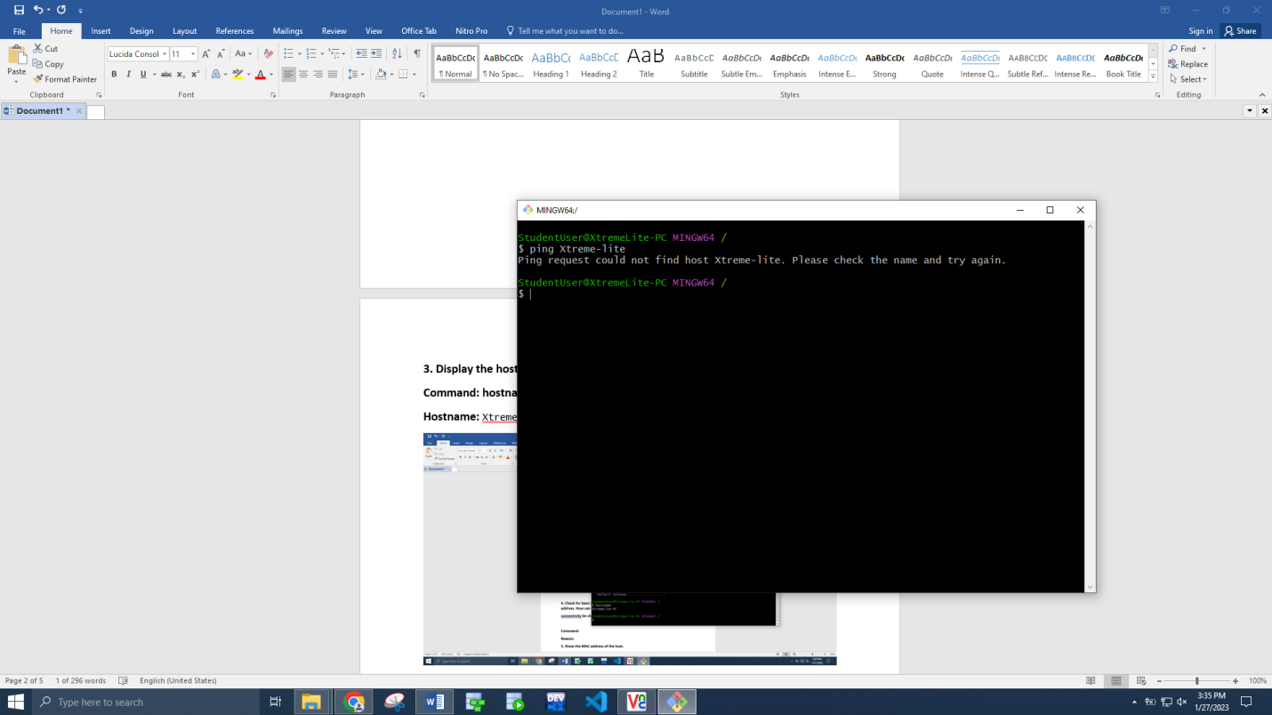

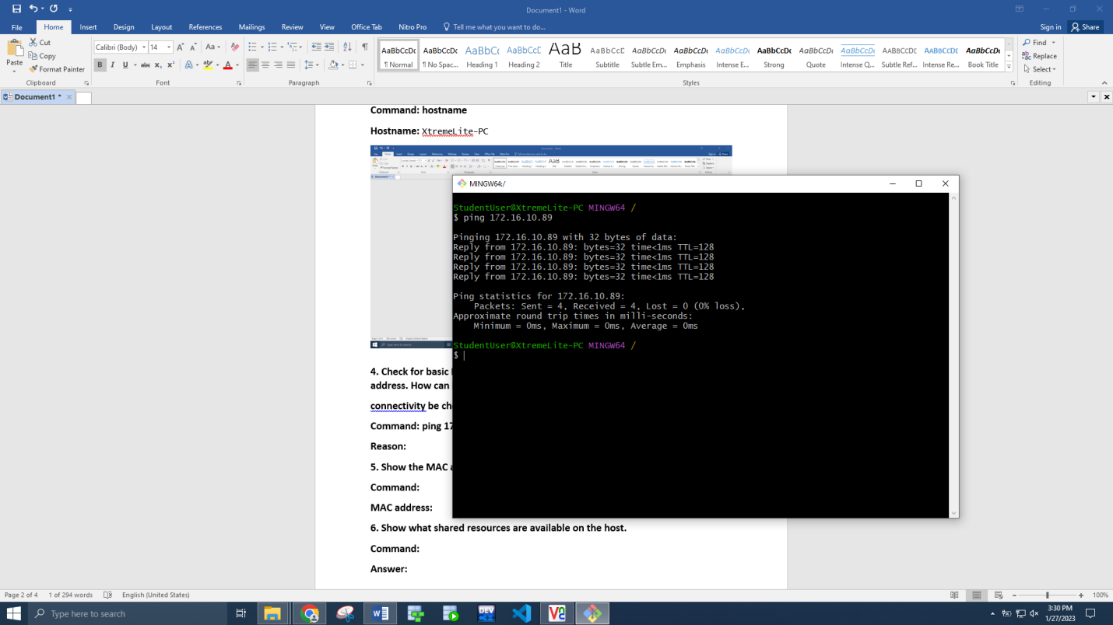

**5. Show the MAC address of the host.**

**Command: getmac**

**MAC address:** 80-FA-5B-32-AC-2D

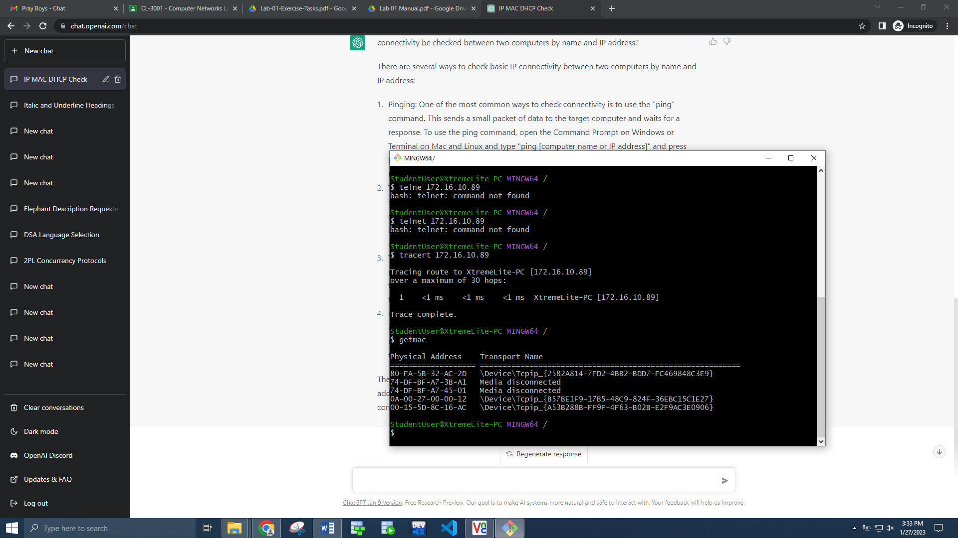

**6. Show what shared resources are available on the host.**

**Command: net share / net view XtremeLite-PC**

**Answer: shared resources are listed below**

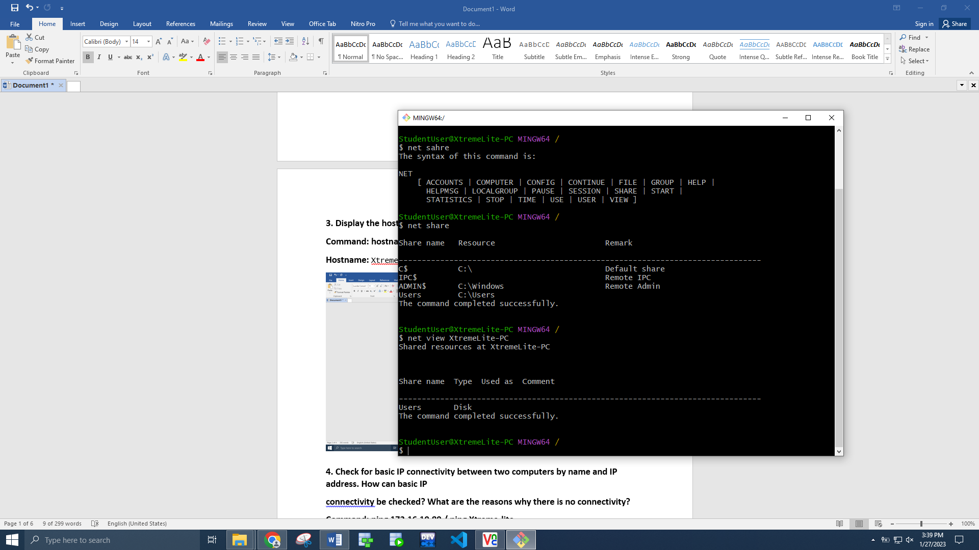

**7. Find out which ports on your host are connected to applications. Connect the browser to some**

**external web page before running the appropriate command.**

**Command: netstat –ano**

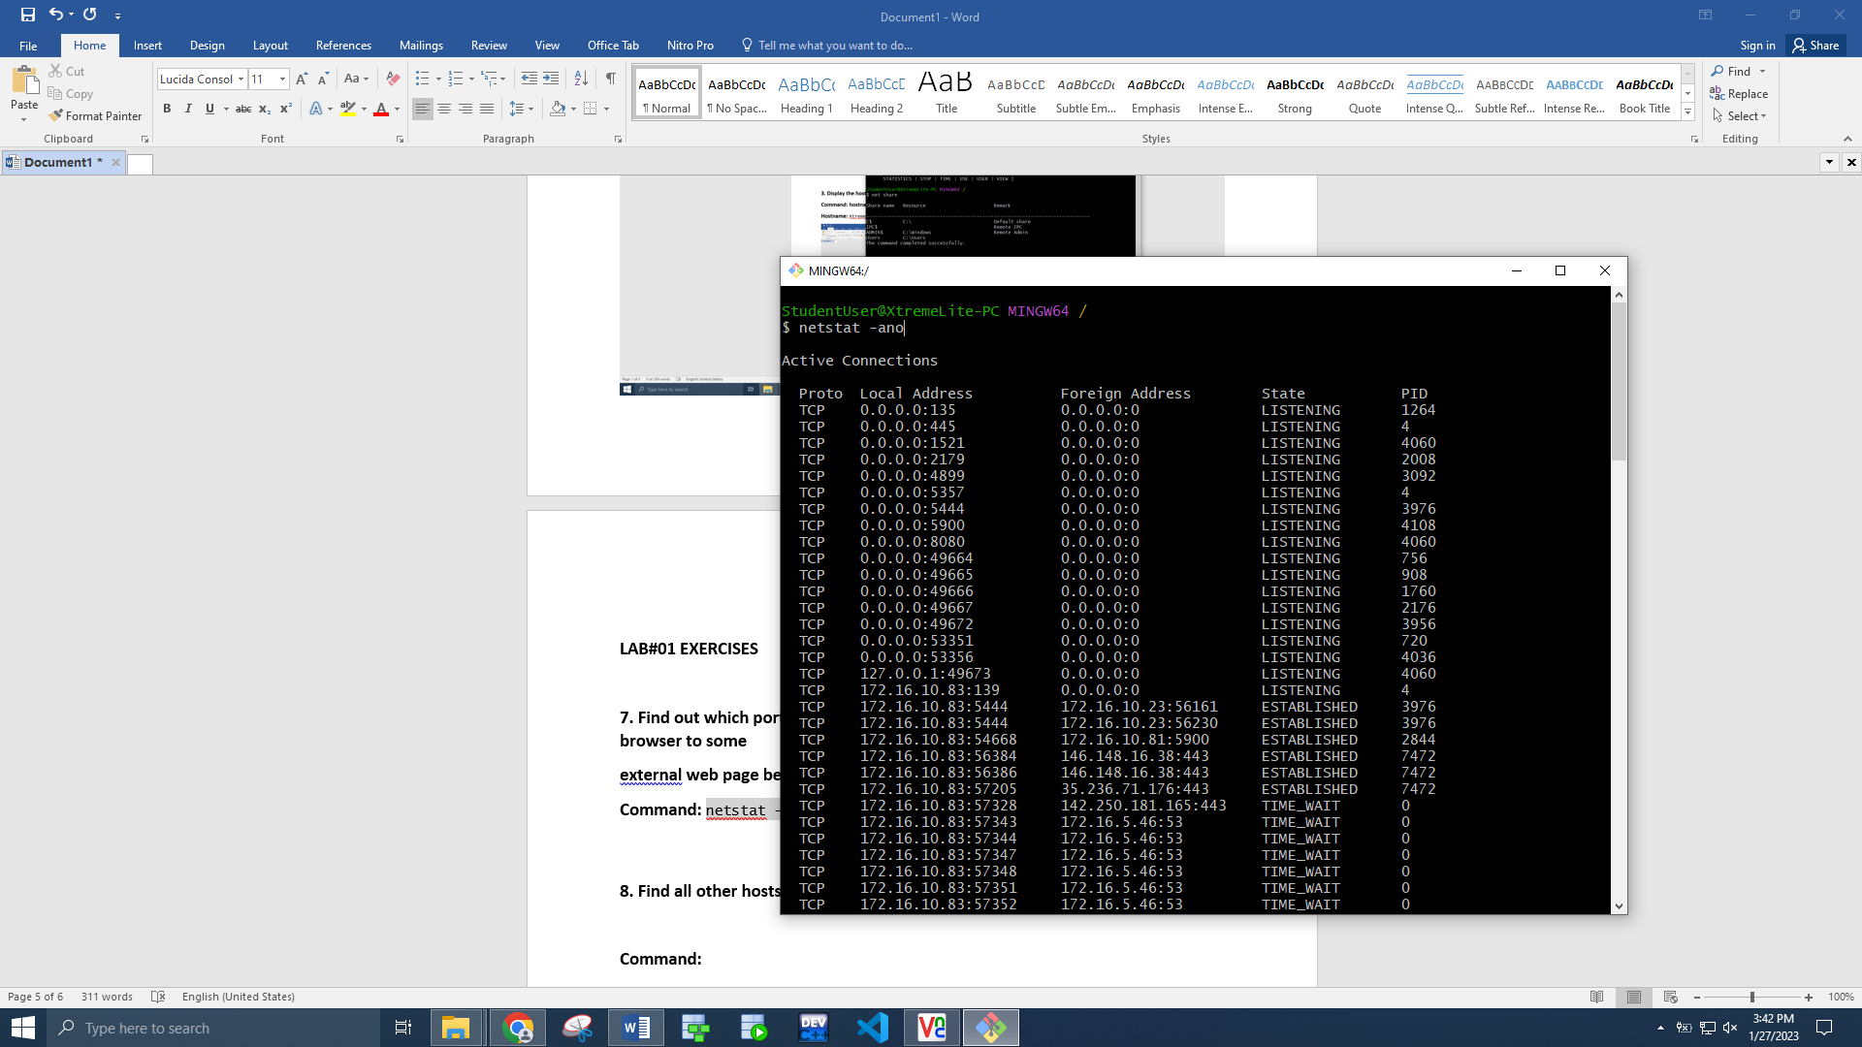

**8. Find all other hosts available on the network.**

**Command: arp -a**

**Answer:**

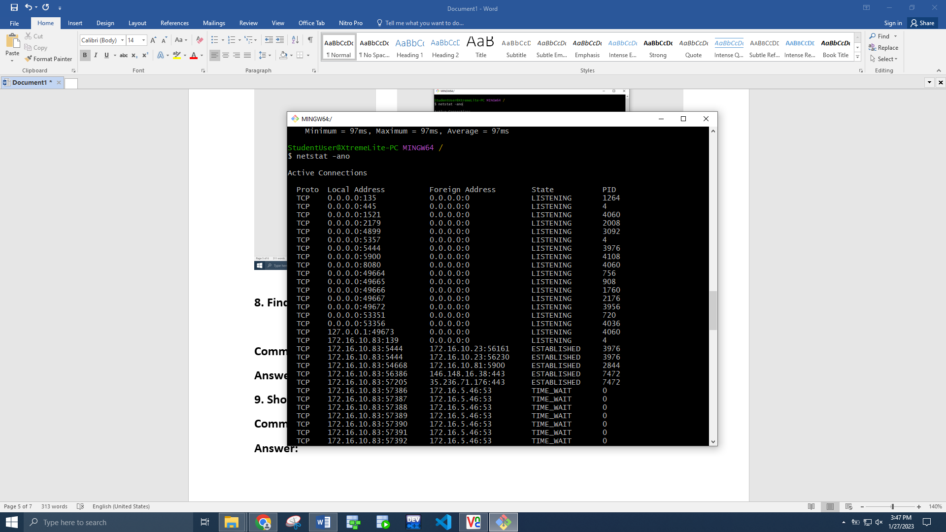

**9. Show the address of the gateway.**

**Command: route print // find gateway**

**Answer:** 172.16.10.1

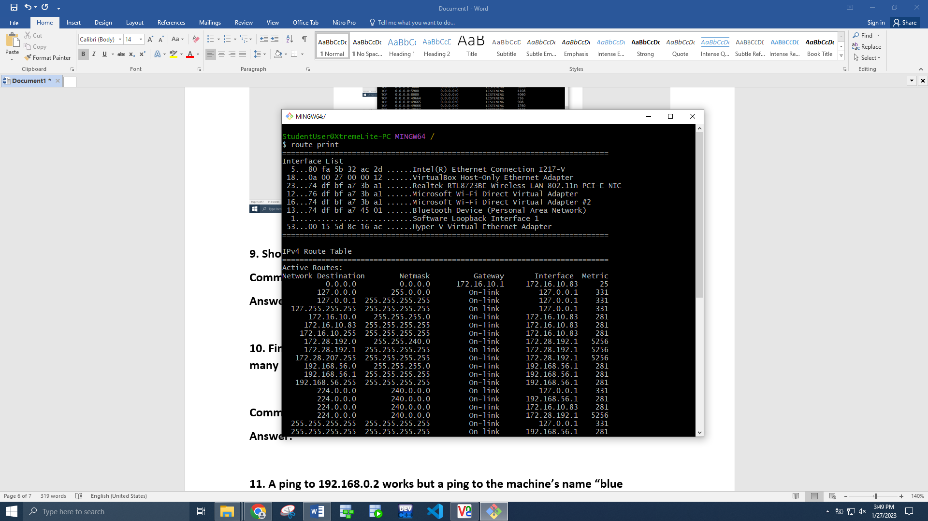

**10. Find the path of routers to www.google.com.What is its IP address? How many hops involvedin the path?**

**Command: tracert [www.google.com](http://www.google.com)**

**Answer: 30 hops**

**11. A ping to 192.168.0.2 works but a ping to the machine’s name “blue machine” fails. What could be**

**wrong?**

**Reason: Machine not on network**

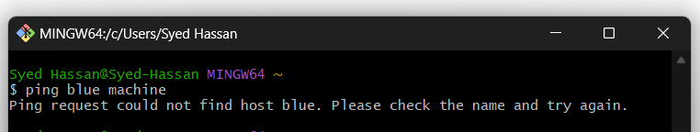

**12. Which type of cable will you use to connect in a normal home installation? Give reasons.**

**Answer: In a normal home installation, the most commonly used type of cable is Category 5e or Category 6 unshielded twisted pair (UTP) cable**

**13. Can you connect a Switch to another Switch or a router to a PC using a straight-through cable? Explain your answer.**

**Answer: Straight cable is mostly used to connect computer to a switch or router because it has same connector on each end (RJ-45). But to connect two switches or a router to a Pc, a crossover cable is used.**

**14. Write a brief report on your home network or any organizational**

**networkincluding topology, 1 page max).**

**Answer: My home network is a simple network that connects a few devices such as laptops, smartphones, tablets, and a printer. The topology of the network is a star topology. All of the devices are connected wirelessly to the router, via Wi-Fi. The wireless network is protected by a strong password and uses WPA2 encryption to ensure the security of the network.**

**15. Find the path of routers to www.yahoo.com What is its IP address? How many hops involved in the path?**

**Answer:**

